**Zach Adair**

**MSDS 650**

**Regis University**

**3/11/2019**

## Week 1 Assignment – Data Analytics

## Introduction of dataset – Iris dataset

The iris dataset looks at three types of iris flower: setosa, versicolor, and virginica to measure the sepal and petal lengths and widths. There are 150 flowers in total, 50 of each.

### Step 1: load the dataset into R and verify data

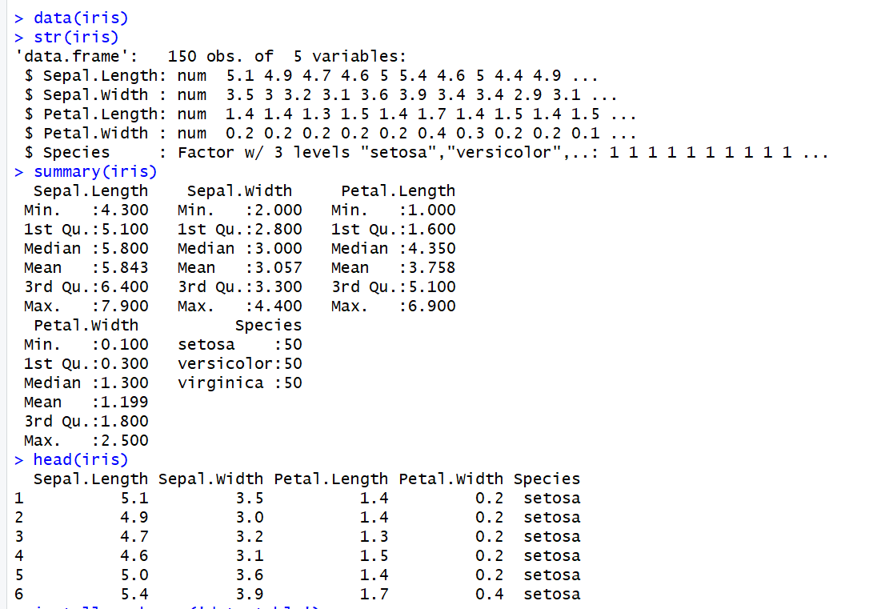

### Step 2: Convert Iris to a Data Table

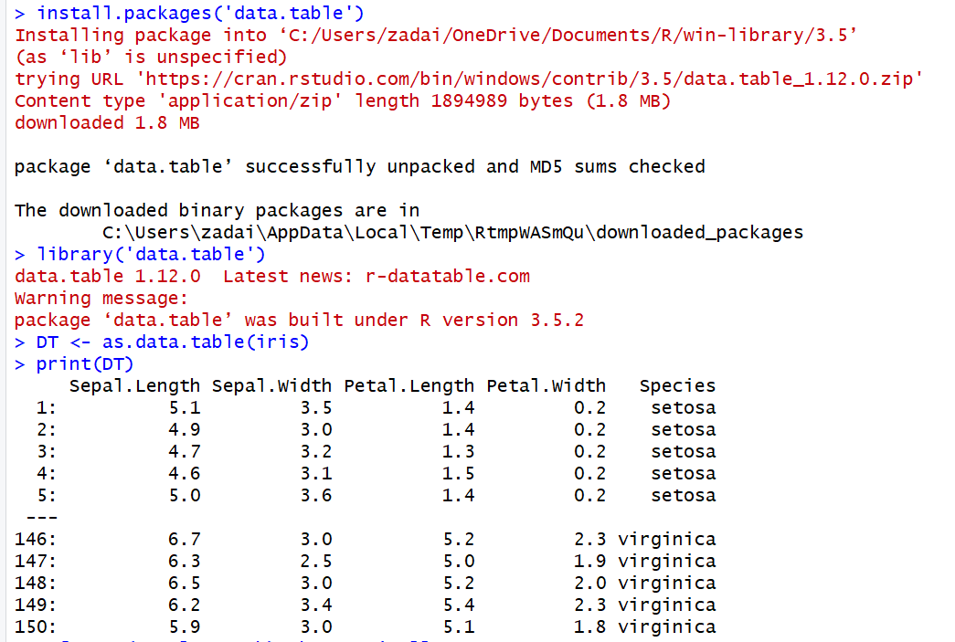

### Step 3: Begin Outputting Summary Functions

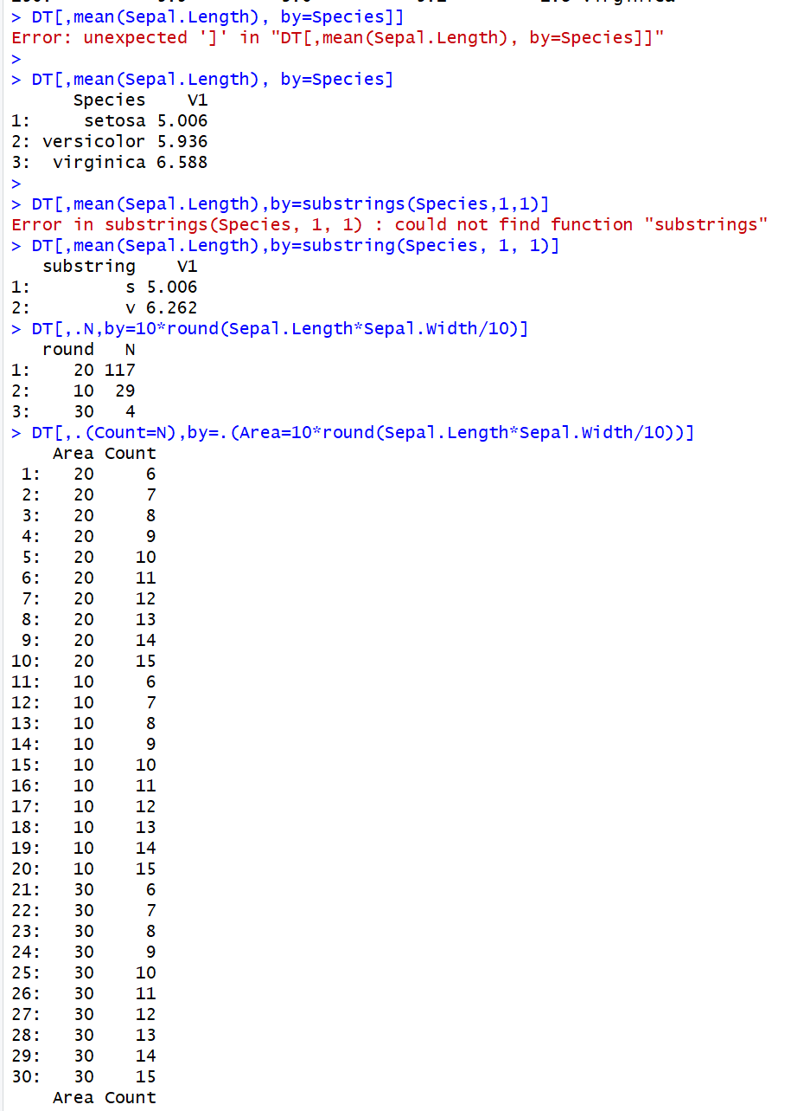

### Step 4: Chaining

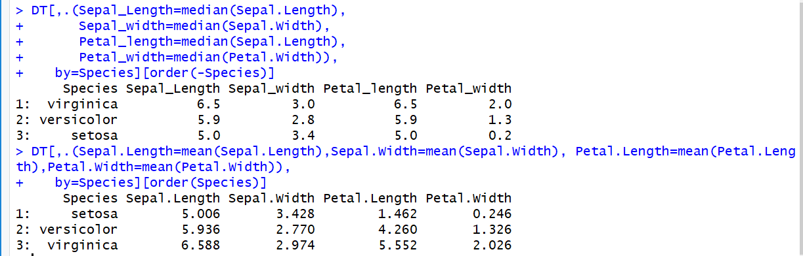

### Step 5: Subset of the data table

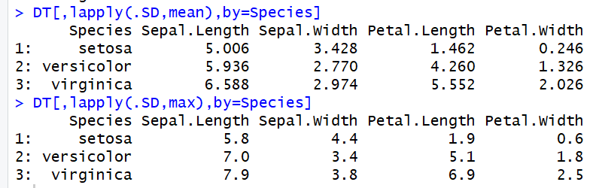

### Step 6: Additional Commands

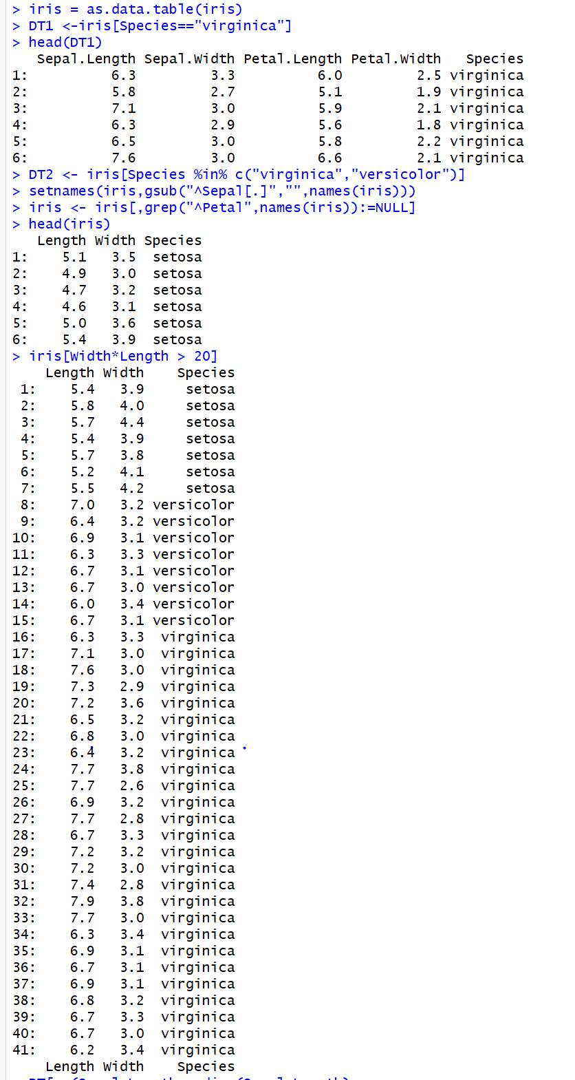

## Summary of the dataset – Iris Dataset

The iris dataset is a great dataset to practice R commands with because it is a set where you can do a lot of different types of analytic techniques on it. You can do descriptive analytics checking out the summary of the data as well as diagnostic style analytics, but as an analyst you are actually able to run predictive analytics with the dataset so there are so many different things you can do to the dataset to learn about the data within it and learn about R or R Studio.

# Dataset on my Own – Cars

### Dataset Introduction – Cars

The cars dataset, like the iris dataset is a preloaded dataset within R. It is a little bit simpler than the iris dataset because it has less fields but it still can be used to create simple descriptive statistics and create neat data models. It only has two fields of measure, speed and distance which analysis can be calculated from. By going through a little analysis in R Studio with the Cars dataset I hope to find out a little bit more about the data within the dataset as well as find out a little bit more about R and the different things you can do within it.

### Step 1: Load and Summarize Cars

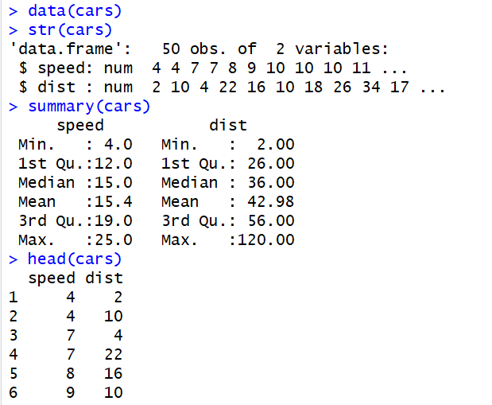

### Step 2: Convert to Cars to a Data Table

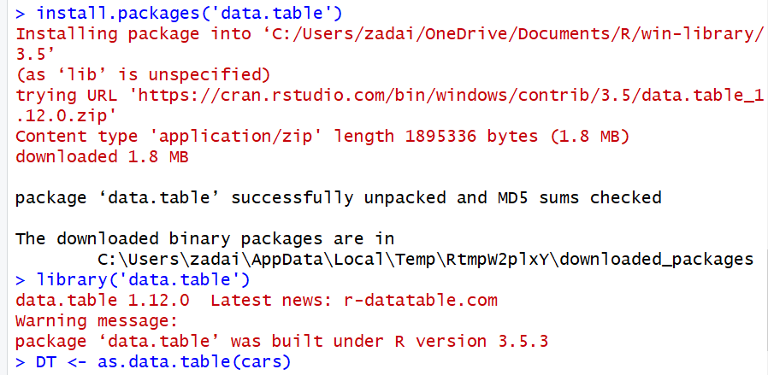

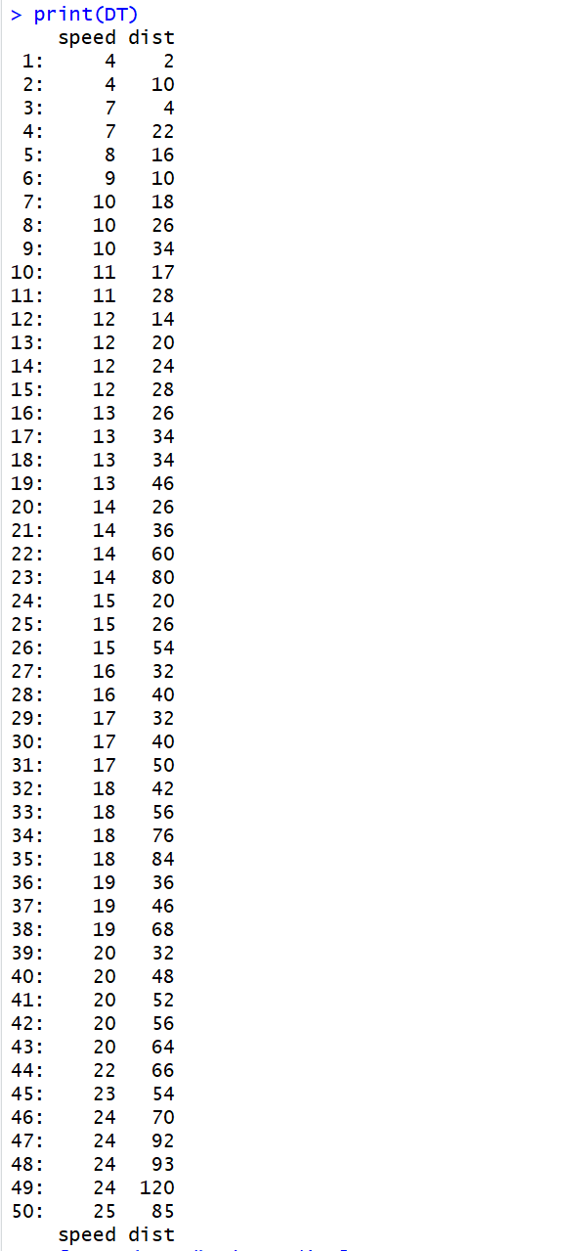

### Step 3: Outputting Summary Functions

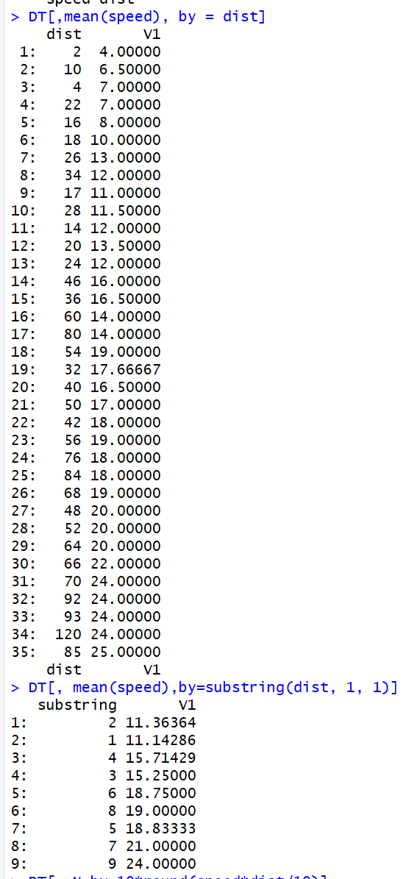

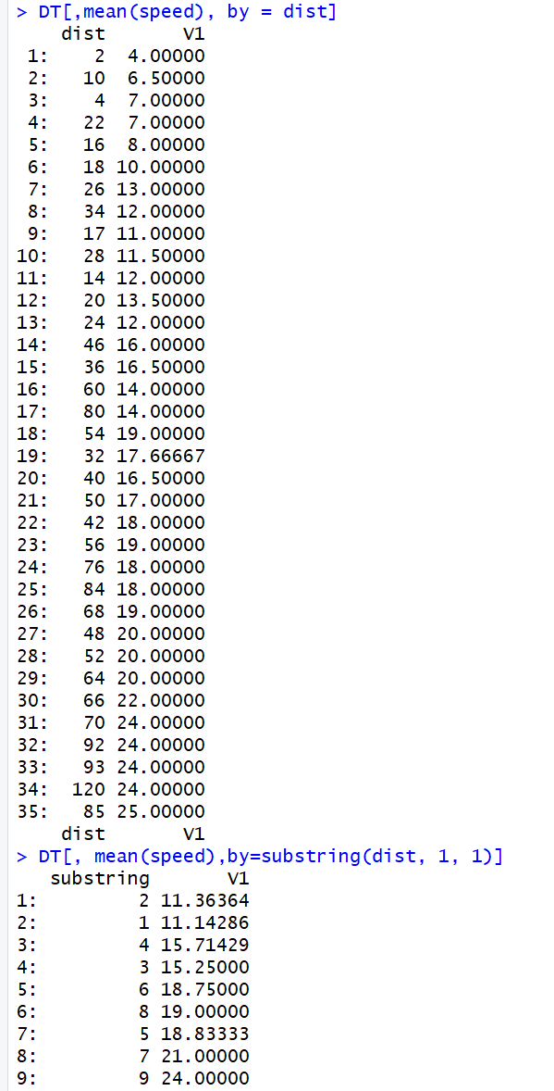

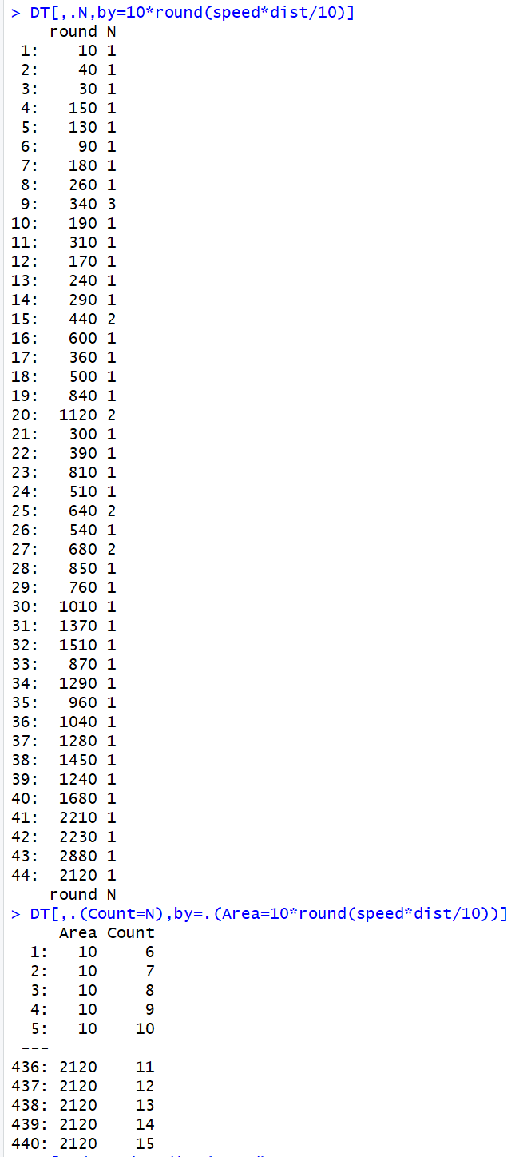

### Step 4: Chaining

Trying the Chaining commands with the Cars dataset was difficult and errored unlike the iris dataset. But I have some linear models built in later which I hope will make up for not being able to Chain commands together.

### Step 5: Subset of the Cars Dataset

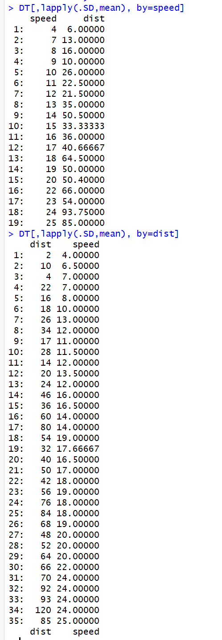

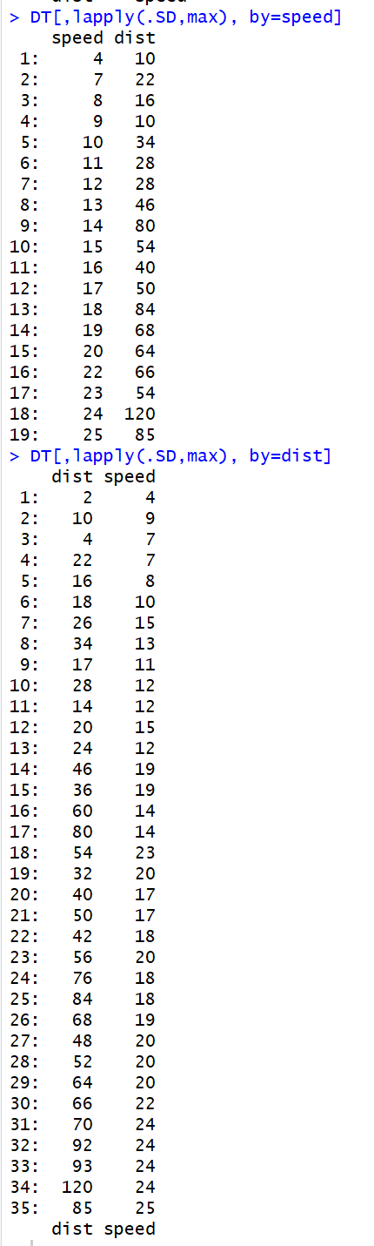

### Step 6: Extra

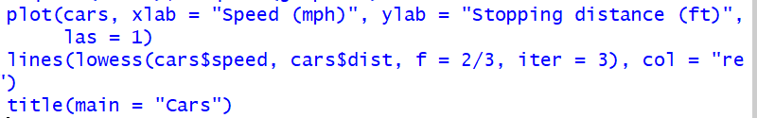

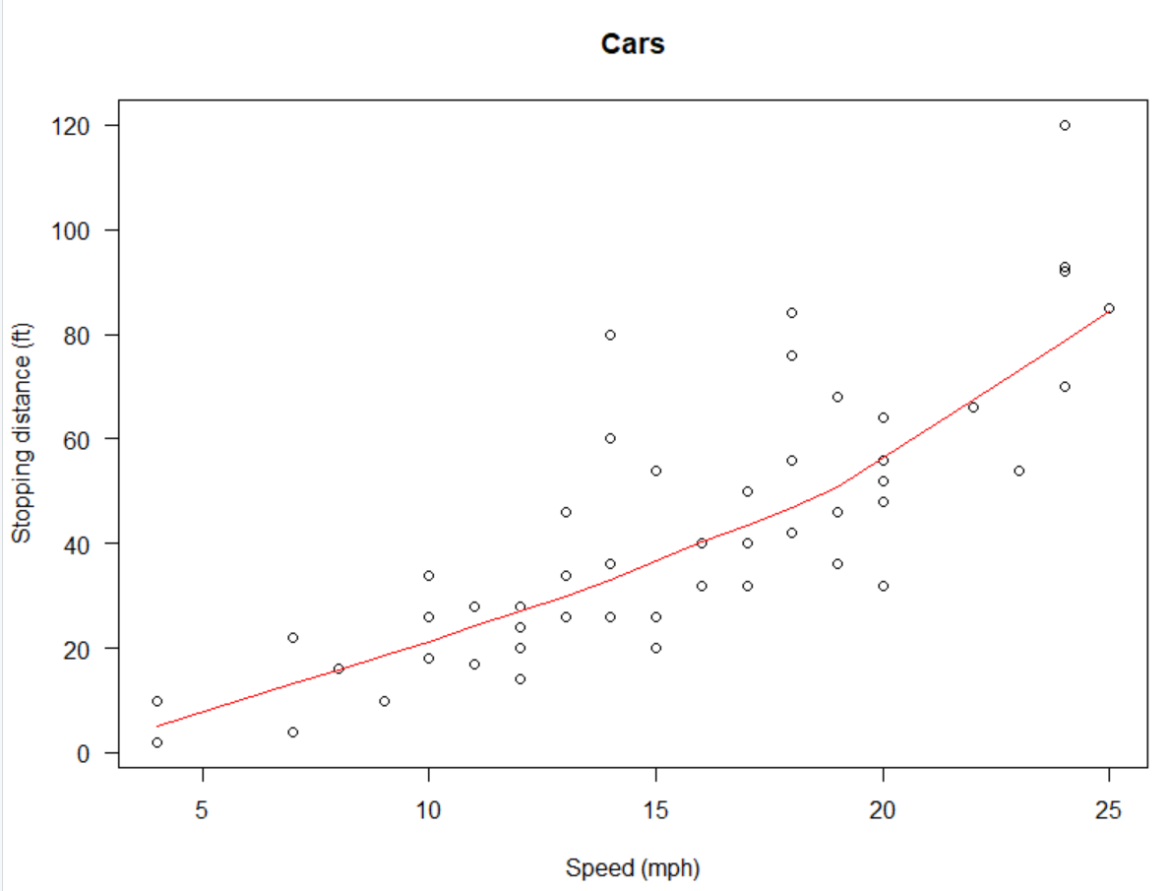



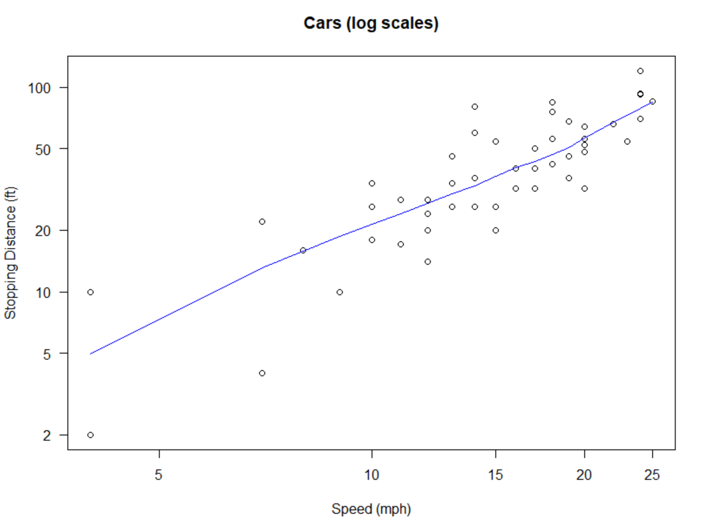

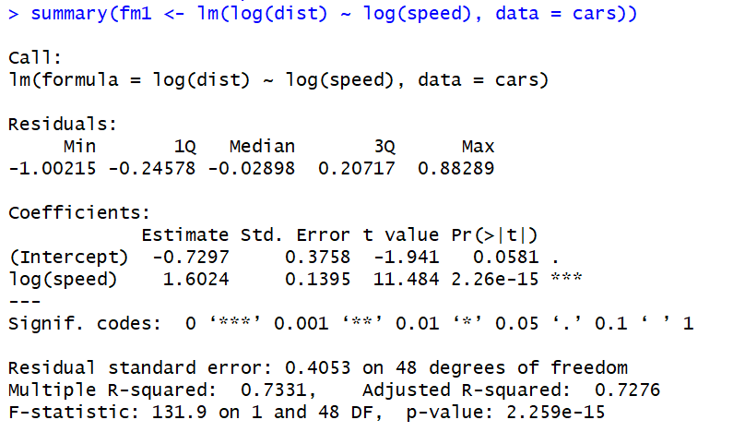

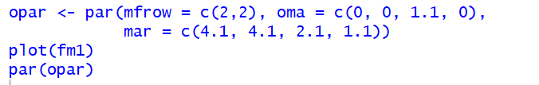

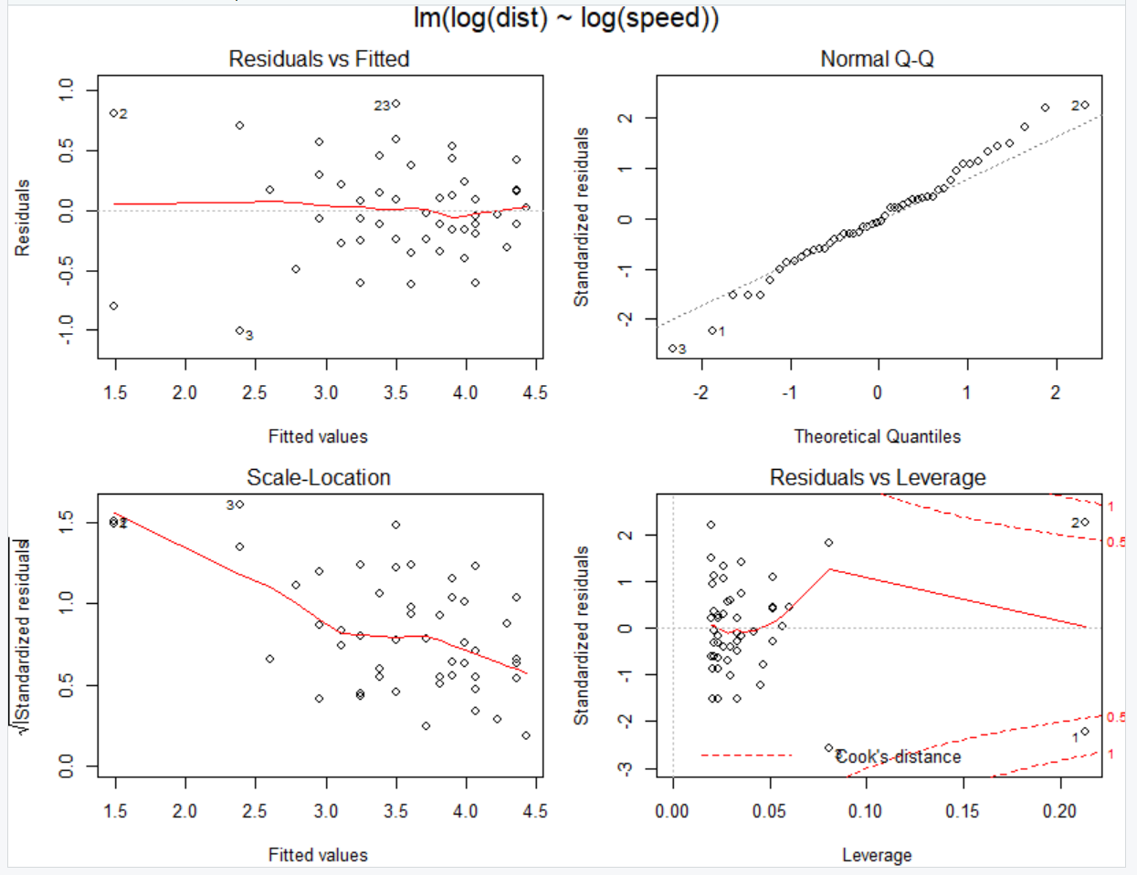

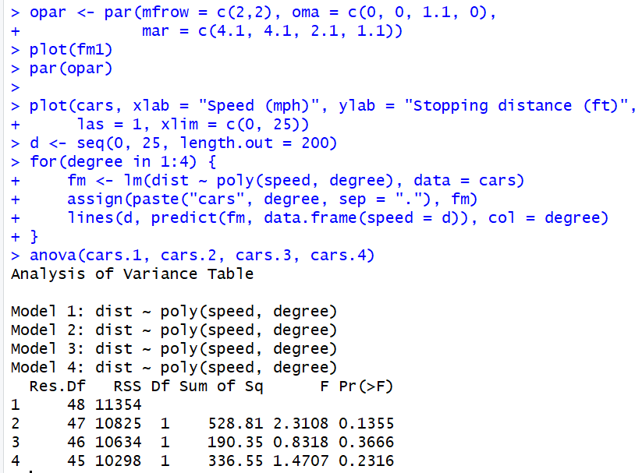

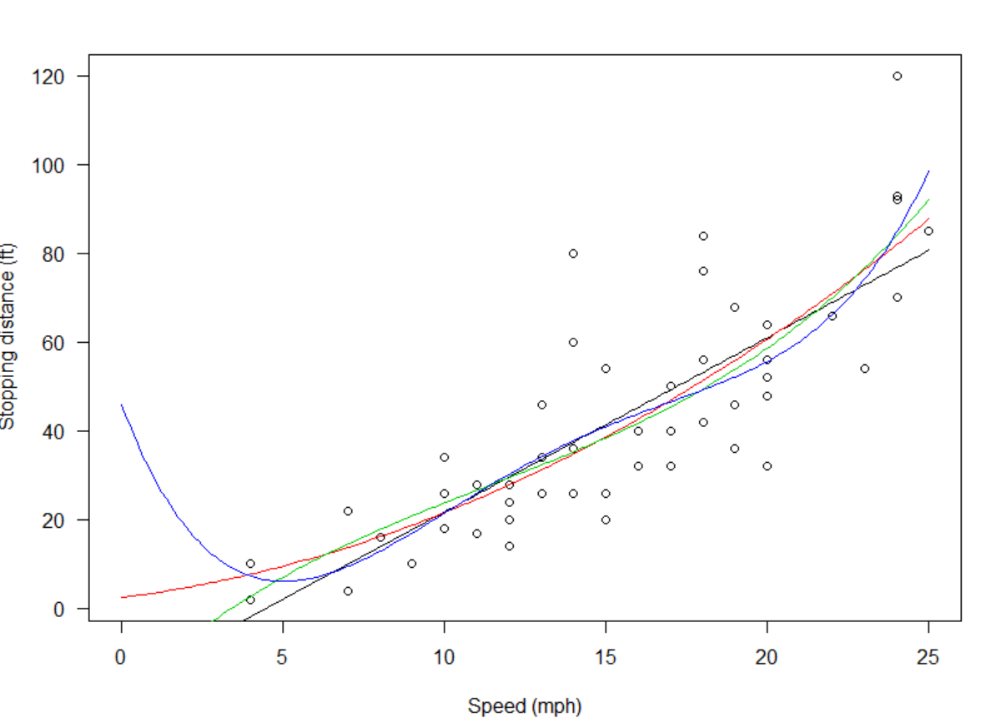

### Summary of the Cars Dataset

Though the dataset is simplistic, even more simplistic than the Iris dataset, the Cars dataset allows for an analyst to use a lot of different statistical methods to analyze the data within it. Users are able to simply summarize the data and see simple statistics figures like the ones R provides within summary statistics or you can construct plots and logarithmic scaled linear models, showing not only how much you can do with the dataset but what is possible with the application itself.